**Ideation Phase**

**Empathize & Discover**

|  |  |
| --- | --- |
| Name | JAGATHEESH B |
| NM Id | 912D6C8E79E54D694A04C468ED615272 |
| Project Name | Creating an Email Campaign in MailChimp |

Link: <https://app.mural.co/t/home8827/m/home8827/1698939106479/c5c8785edda409973ebdcba608aa09c4e8d1d9ec?sender=udac632c72e02186ce1712886>

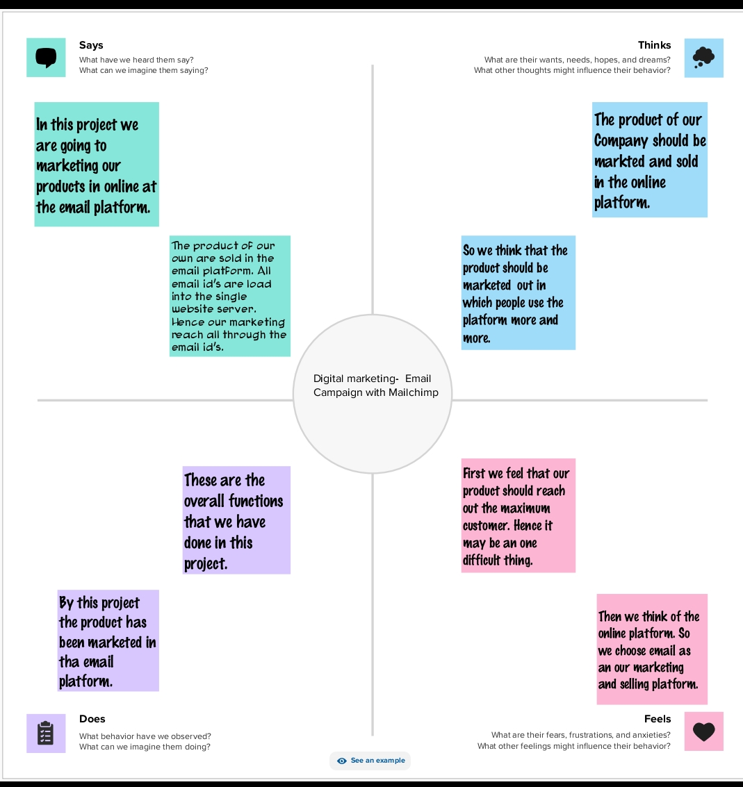

**Brainstorm & Prioritize Ideas**

**Link:** [**https://app.mural.co/t/home8827/m/home8827/1699010542977/cc90a658a1d76bd0b2ade279d9a0c9e97b187d2e?sender=udac632c72e02186ce1712886**](https://app.mural.co/t/home8827/m/home8827/1699010542977/cc90a658a1d76bd0b2ade279d9a0c9e97b187d2e?sender=udac632c72e02186ce1712886)

